**Investor Portal Mobile Version recipient guide**

Contents

**1** **Set up Password AutoFill** 1

**2** **Accessing the Investor Portal with Biometrics** 3

**3** **Add Investor Portal as Home Screen App** 6

**4** **Download A Document** 10

# **Set up Password AutoFill**

**iPad or iPhone:**

1. Open Settings, swipe down, and tap Passwords & Accounts.
2. Tap AutoFill Passwords, then tap the toggle next to AutoFill Passwords.
3. You will also want to have iCloud Keychain turned on if you do not already (Settings → your name → iCloud → Keychain).
4. Now you will be able to save and AutoFill passwords on the web and in apps, look for the prompt at the bottom of your iPhone when tapping on a password field.

Keep in mind if you are turning on AutoFill/iCloud Keychain for the first time, you will need to save your passwords as you type them in during daily use. Then upon using them the next time, you will be able to use AutoFill for the saved credentials.

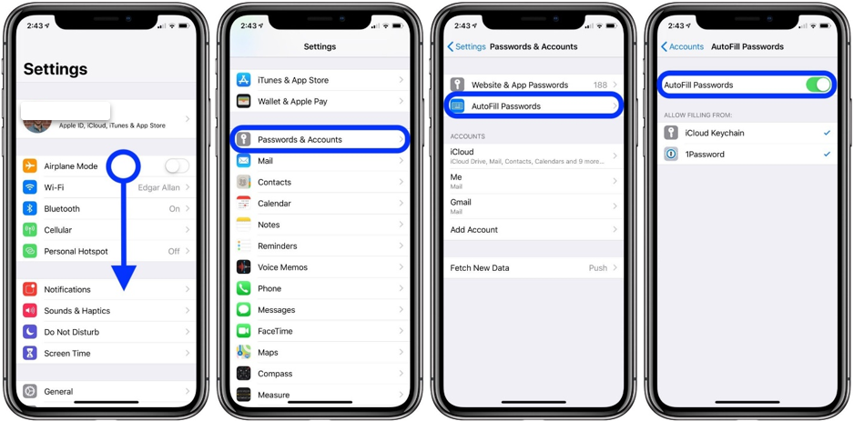

As shown in the far-right screenshot above, you can also use third-party password managers like 1Password with AutoFill or opt to use both iCloud Keychain and a third-party app.

**Android:**

**On Android, the autofill feature uses Google’s own password management service to enter your username and password into apps, though it will work with other password manager apps as well. It is only available for Android 8.0 and above.**

1. **Open the Settings app on your Android device.**

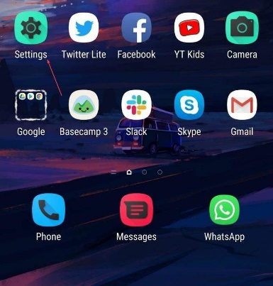

1. Go to General Management (or System).

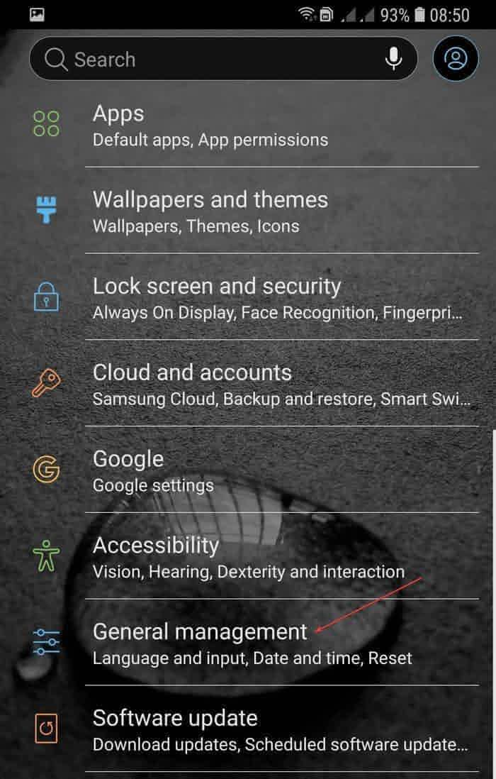

1. Go to Language and Time and tap on “Language and input.”

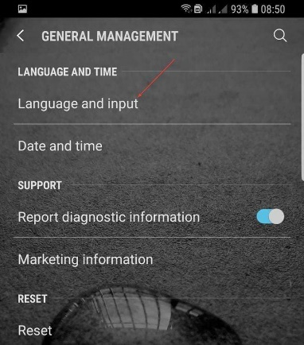

1. Find Input Assistance (or Expand Advanced Settings) and tap on Autofill service.

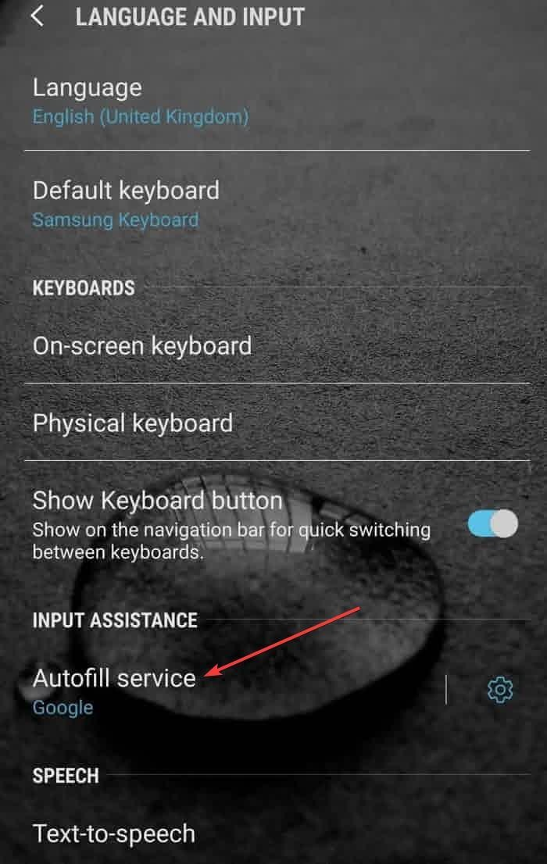

1. Tap on the Google option to select it (if this is the default service you would like to use). If you want to use a third-party autofill app, tap on “Add Service.” The apps currently compatible for this are Enpass, LastPass, Dashlane, Keeper, and 1Password.

# **Accessing the Investor Portal with Biometrics**

**iPad or iPhone:**

After logging in for the first time and saving your password, you may use TouchID or FaceID to securely access your investor portal going forward.

Log into the investor portal for the first time to save your credentials:

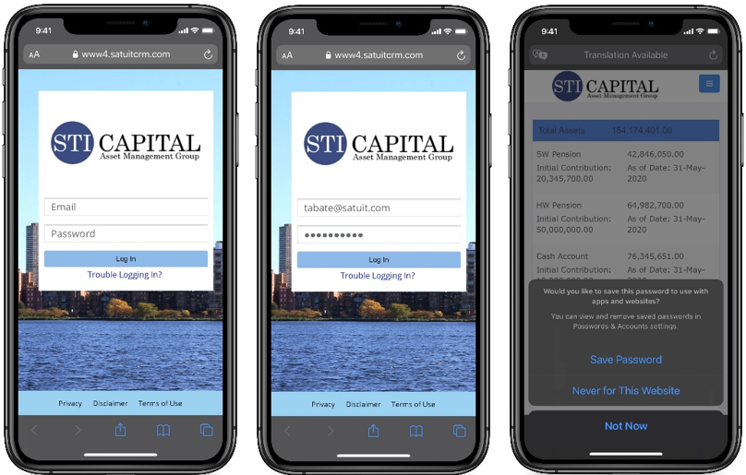

Once you have successfully saved your password, you will be able to use your phone's biometrics to manage logins.

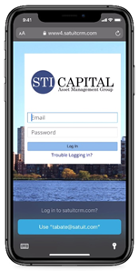

1. When you insert your cursor in the email and/or password field of the investor portal, you will have the ability to select your saved account highlighted in light blue on the bottom of your device. In the above example you would click Use "tabate@satuit.com".

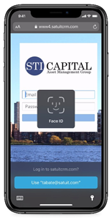

1. Once you select your stored account information, you will be prompted to authenticate with your iPhone's preferred biometric, FaceID or TouchID.

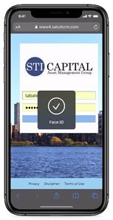

1. After successful verification, your credentials will be automatically inserted into the Email and Password field.

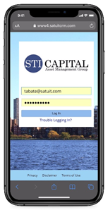

1. Now you simply click the "Log In" button in the middle of the screen to access your investor portal.

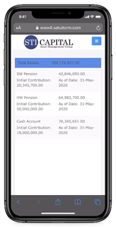

1. Success!

**Android:**

1. Open your investor portal web page sign in when prompted. Once you are successfully signed in, Android Oreo will offer to save your login credentials to Google or the third-party app you are signed into.
2. When you open the web page or app and tap “Sign In,” your email address will appear as a suggested option.
3. For third-party apps you will get a prompt to unlock your password manager and select the credentials to use without leaving the login screen.

# **Add Investor Portal as Home Screen App**

**iPad or iPhone:**

1. Launch Safari on your ‌iPhone‌ or ‌iPad‌ and open your investor portal web page.

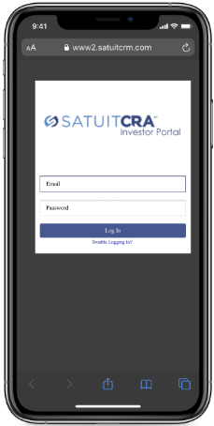

1. Tap the Share icon (the square with an arrow pointing out of it) at the bottom of the screen.

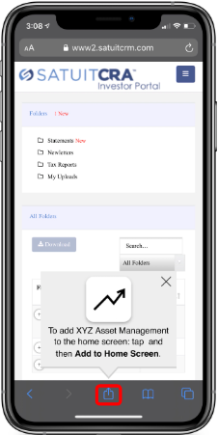

1. Scroll down to the list of actions and tap **Add to Home Screen.** (If you do **not** see the action, scroll to the bottom and tap **Edit Actions**, then tap **Add** next to the **Add to ‌Home Screen‌** action. After that, you **will** be able to select it from the Share Sheet).

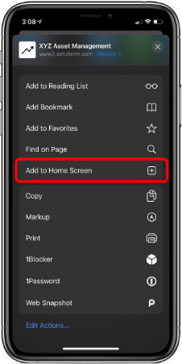

1. Type a name for your site link. This will be the title that appears beneath its icon on your Home screen. Then tap Add in the top-right corner of the screen.

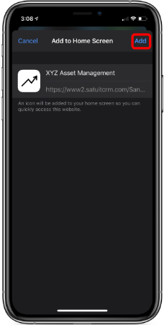

1. Your new "Investor Portal app" will appear in the next available space on your device's Home screen. To move it like you would any other app, tap and hold its icon, then tap Edit ‌Home Screen‌, and you will be able to drag it to your desired location. When you have placed it where you want it, tap Done.

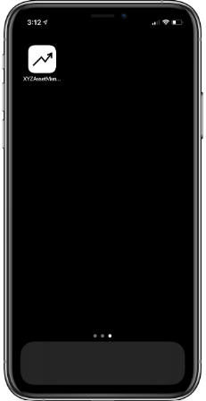

**Android:**

1. Launch Chrome app, open your investor portal web page and log in.

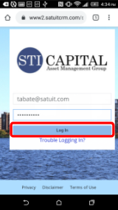

1. Tap the menu icon (3 dots in upper right-hand corner) and tap Add to home screen.

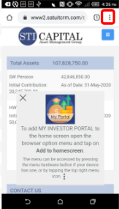 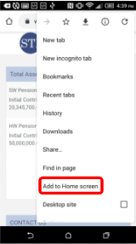

1. You will be able to enter a name for the shortcut and then Chrome will add it to your home screen.

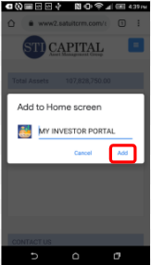

1. You now have an app for your investor portal.

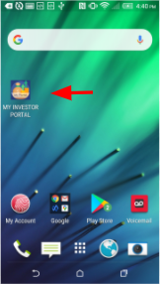

# **Download A Document**

**iPad or iPhone:**

1. Select the hamburger menu in the top right.

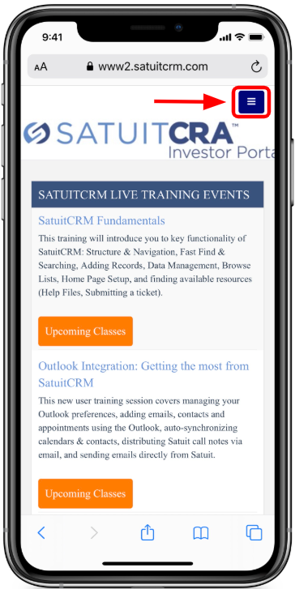

1. Select "Documents".

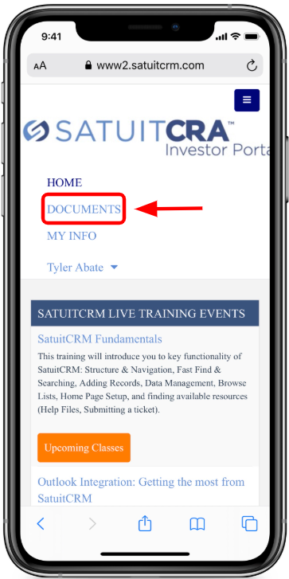

1. Select the folder to view the document contents or scroll down to see all documents.

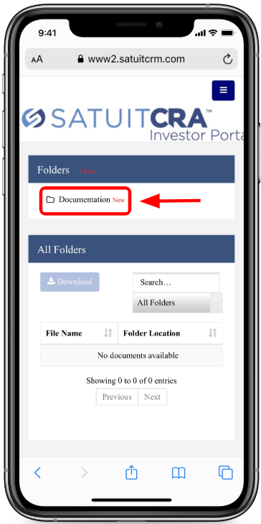

1. Select the document you wish to download.

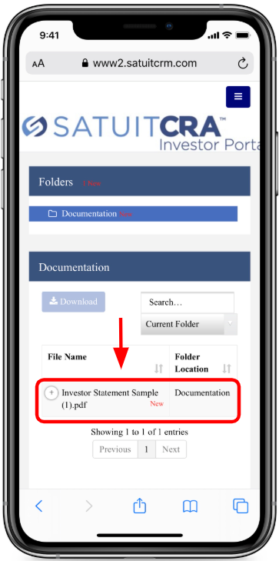

1. Now select the "Download" button, which is highlighted.

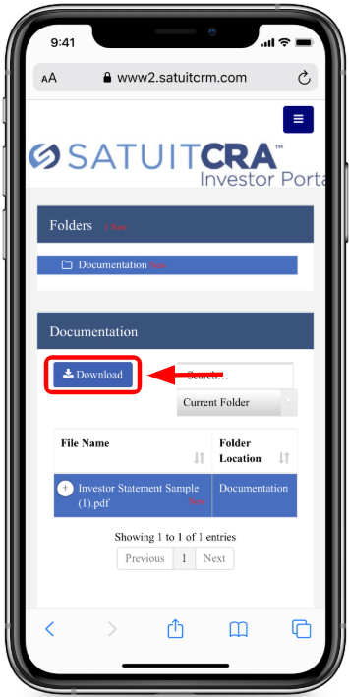

1. A pop-up from Apple will appear confirming you want to download the document.

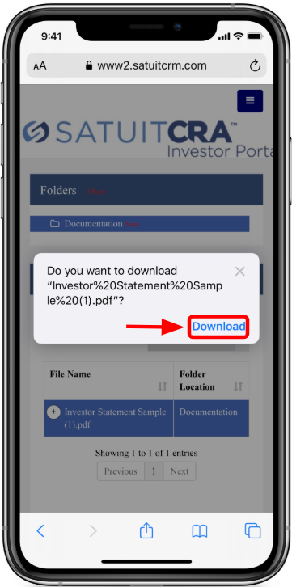

1. Once you click the Apple prompt "Download" it will continue downloading in the background, which is shown in the top right of Safari. Select the circle with the down arrow.

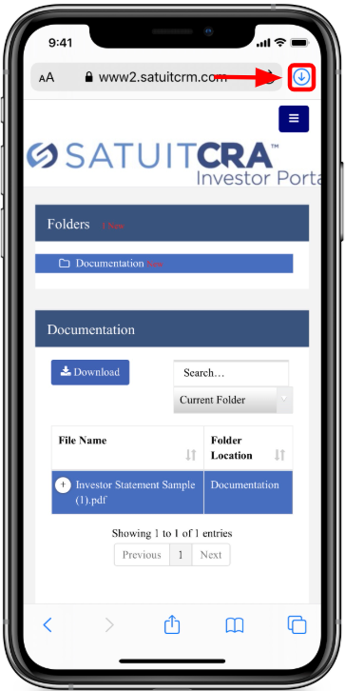

1. Click the file to open it.

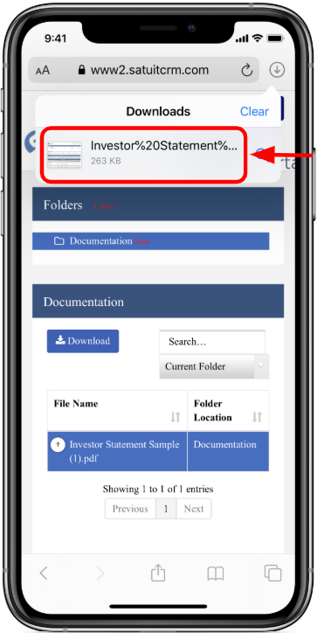

1. Once the document is open, you may use the iOS Share Sheet to action the document.

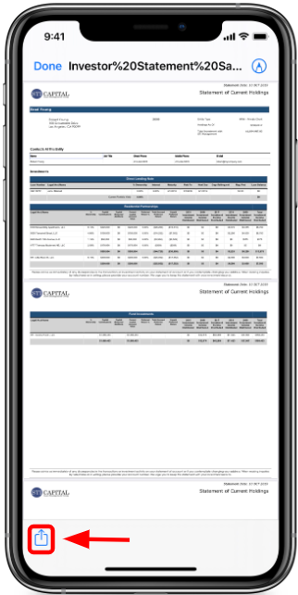

**Android:**

1. Select the hamburger menu in the top right.

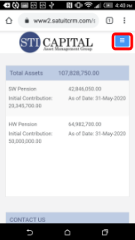

1. Select "REPORTS, DATA & FORMS".

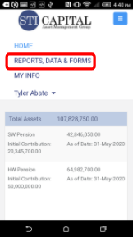

1. Select the folder to view the document contents or scroll down to see all documents. Select the document you wish to download.

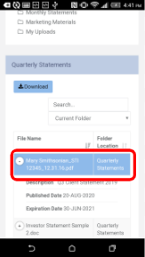

1. Tap Now select the "Download" button, which is highlighted.

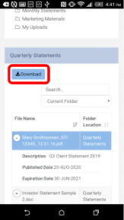

1. Now you can send the document to your desired location.

